**Data Flow Diagrams**

|  |  |
| --- | --- |
| Date | 11 February 2023 |
| Project Name | Project Management Tool |
| Team Members | Indra Shekar G(19z219)  Sanjai M (19z241)  Soumen Saha (19z245)  Vivekanandhan S (19z261)  Manoj S (19z263)  Harish N R (20z431 ) |

**Data Flow Diagrams:**

A Data Flow Diagram (DFD) is a traditional visual representation of the information flows within a system. A neat and clear DFD can depict the right amount of the system requirement graphically. It shows how data enters and leaves the system, what changes the information, and where data is stored.

**0 – LEVEL DATA FLOW DIAGRAM:**

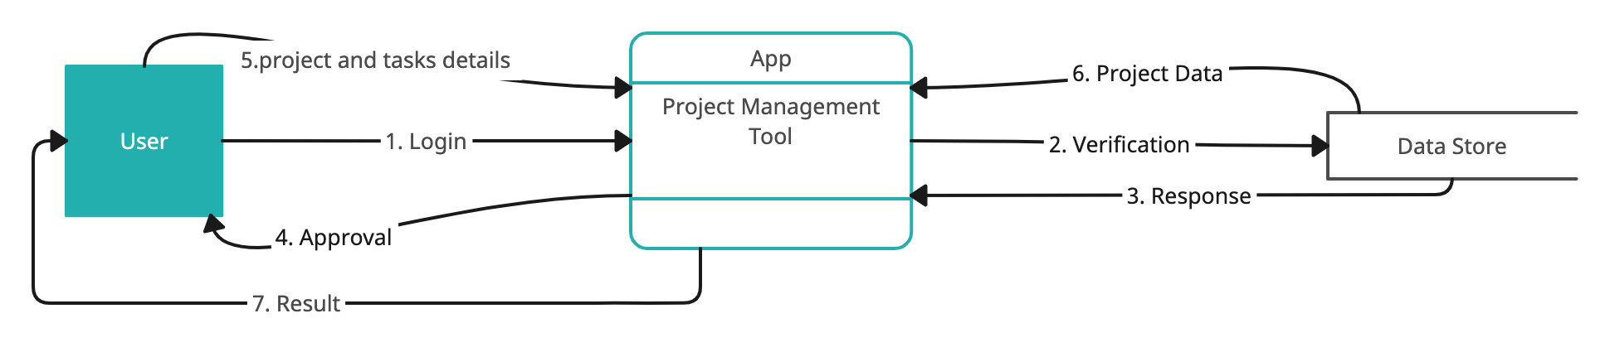

1. User logins to the application using his or her credentials.  
2. Verification of credentials is done using the data stored in the database.

3. Application getting the response from the database.

4. Approval of login or else an error message for incorrect credentials.  
5. Project details and tasks allotted for individual user is retrieved from data store.

6. Application getting the data corresponding to individual user.

7. The result has been sent to the user which then is displayed on the UI.